1.0 INTRODUCTION

In modern software engineering, security cannot be handled as a reactive, post-deployment process. Secure code review is a foundational defensive practice within the software development lifecycle (SDLC) that targets architectural anomalies, functional coding flaws, and systemic misconfigurations before code is compiled or moved to a production release. By evaluating the source code directly, developers can locate hidden vulnerabilities that perimeter defenses—like traditional network firewalls—might fail to intercept.

1.1 OBJECTIVES

The primary technical objectives of this engineering lifecycle lab are:

To construct a functional web application pipeline using the lightweight Python Flask framework to handle client-side routing.

To implement a localized relational database interface using the SQLite database engine to evaluate data-driven interaction pathways.

To deploy automated Static Application Security Testing (SAST) tooling to scan code logic dynamically for vulnerabilities.

To apply secure development principles—specifically database query parameterization and server configuration hardening—to eliminate uncovered security risks.

2.0 INSTALLING PYLANCE EXTENSION
I successfully installed the Pylance extension installed in the Visual Studio Code to improve Python development support. Pylance provides intelligent code completion, syntax highlighting, error detection, and enhanced code analysis features which assist during secure coding review and vulnerability identification of this project
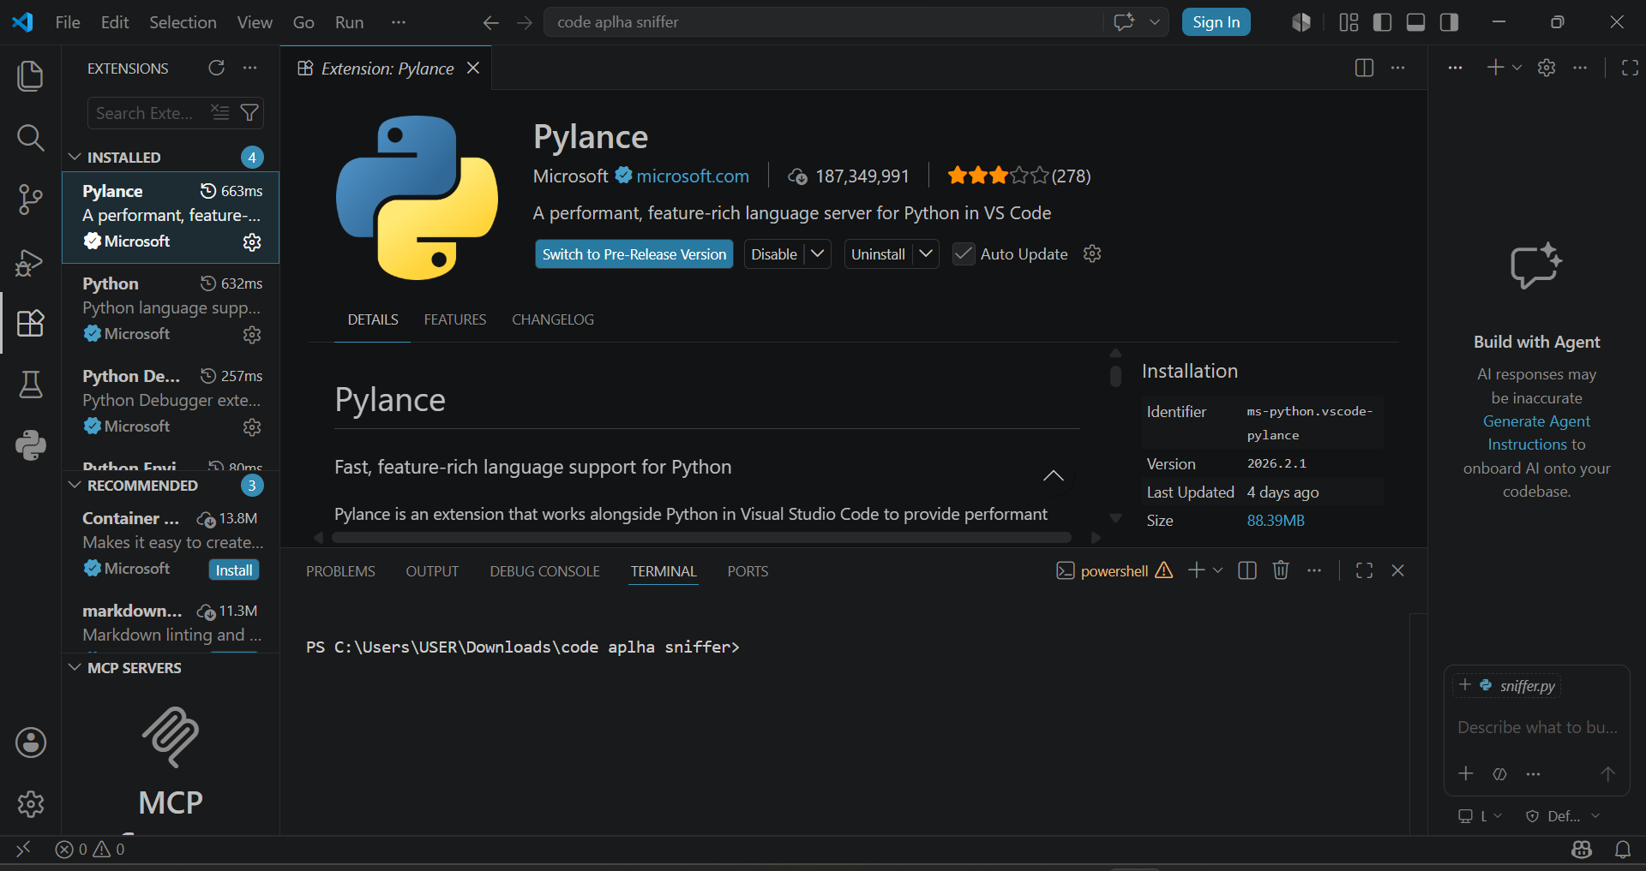

3.0 CREATING THE APPLICATION FILE
I created a Python application file named app.py inside the project workspace. This file contains the web application code that will be reviewed for security vulnerabilities of this project
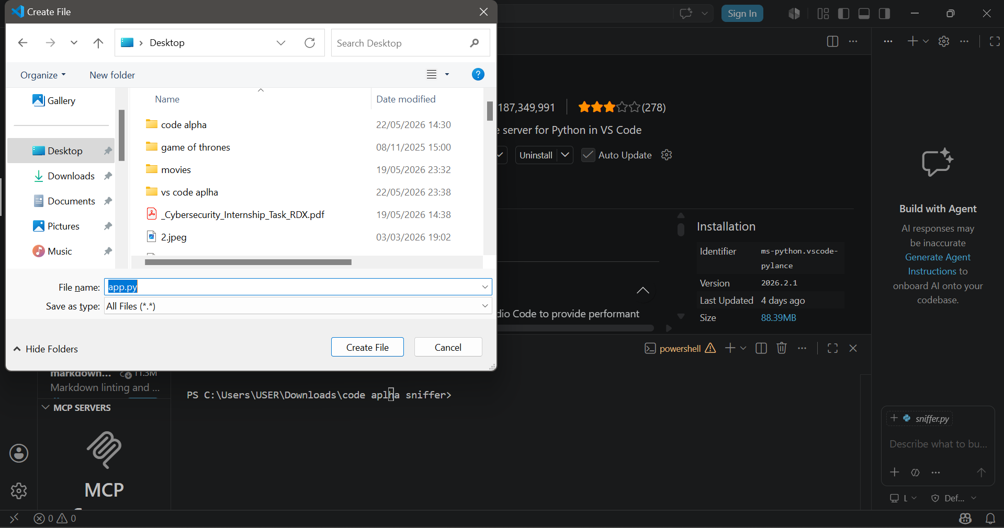

3.1 DEVELOPING THE TEST APPLICATION
I developed a simple Flask web application to demonstrate common coding vulnerabilities. The code intentionally contains insecure practices such as SQL query concatenation and enabled debug mode for security analysis purposes that would be carried out in this project.
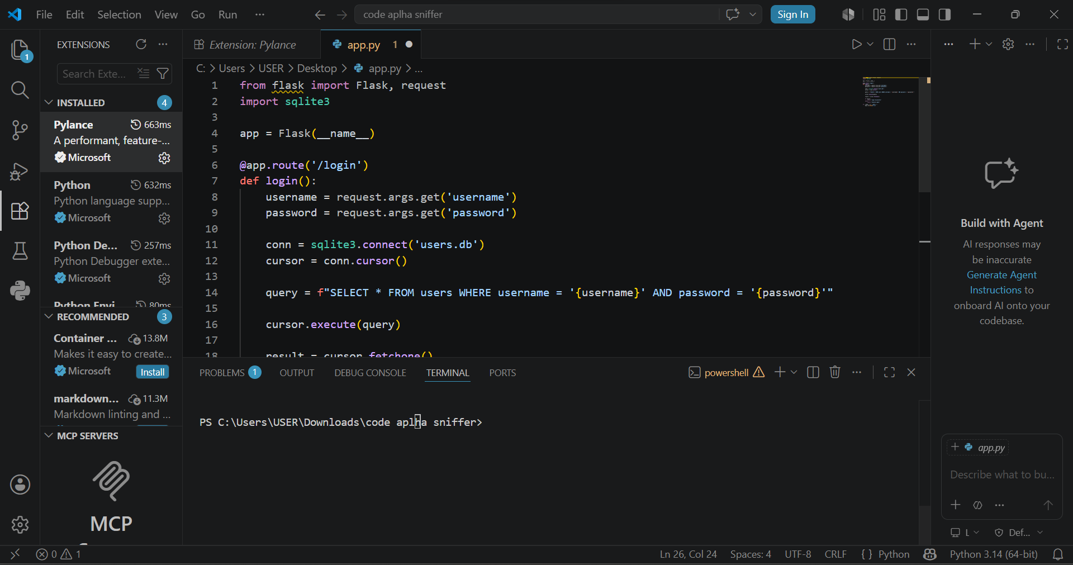

4.0 INSTALLING FLASK FRAMEWORK
I successfully installed the flask web frame work using the Python package manager (pip) within the Visual Studio Code terminal. Flask was selected because it provides a lightweight environment for developing and testing web applications during the secure coding review process.

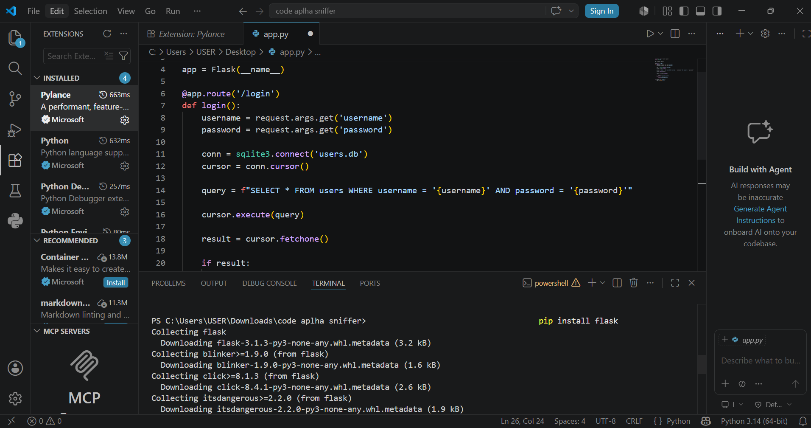
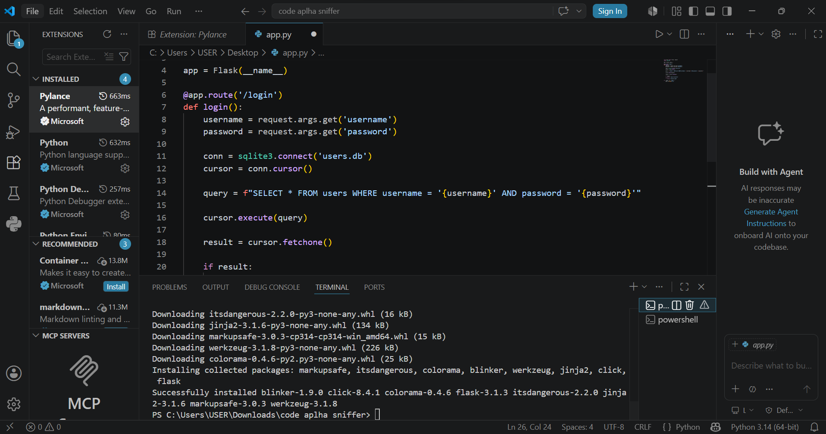

5.0 LAUNCHING THE TARGET WEB APPLICATION
The local development environment was initialized by navigating the command-line terminal to the working directory containing the application source files. The Flask web application (app.py) was executed via the Python runtime, starting a local routing engine listening on localhost port 5000 (http://127.0.0.1:5000). This confirms that the back-end infrastructure is fully active and ready to handle test traffic for vulnerability assessment that would be carried out in the project
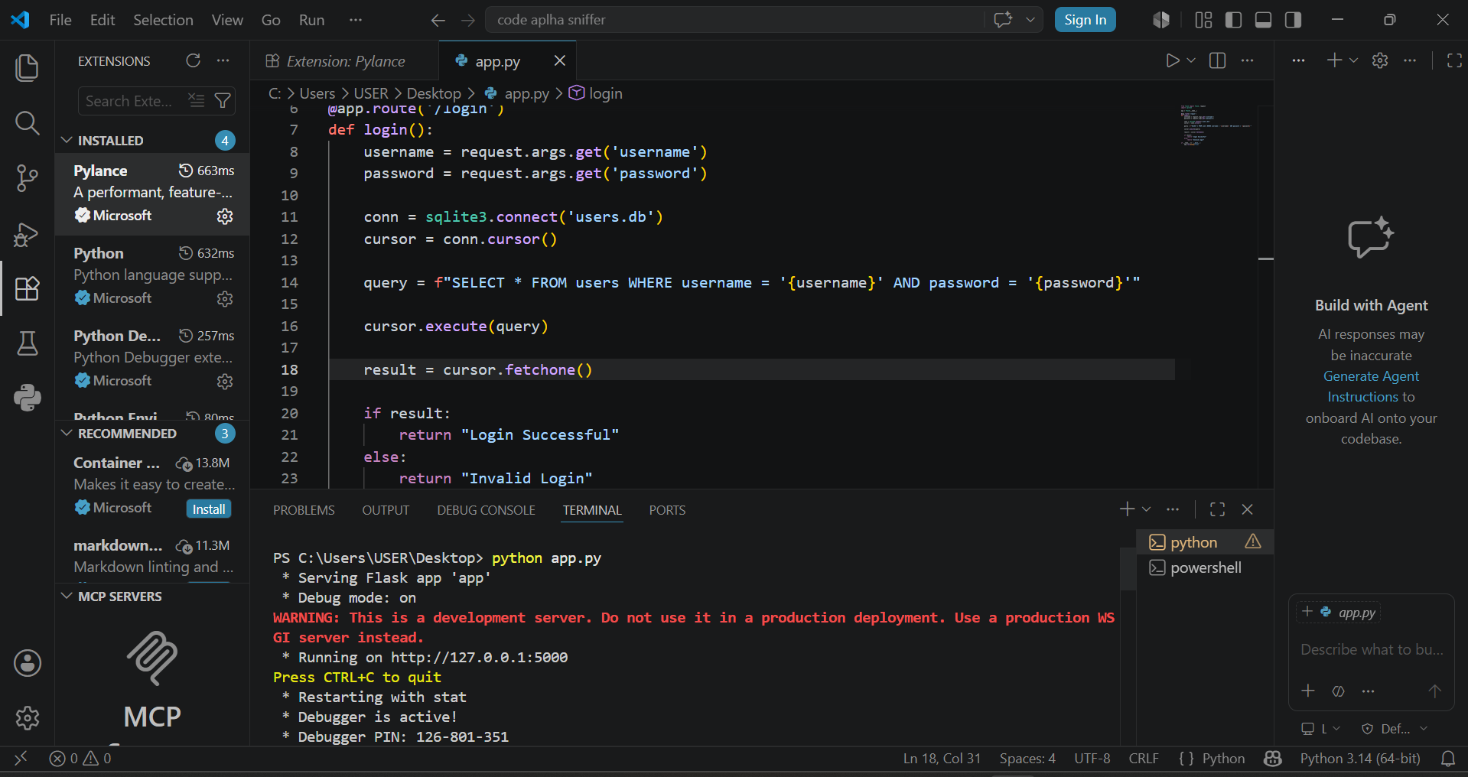
5.1 LIVE INTERFACE TESTING AND INFORMATION DISCLOSURE VULNERABILITY
An interface interaction test was executed by submitting structured test parameters via the client browser to the /login route. The application failed to execute the backend database query due to an uninitialized database table structure, triggering a fatal runtime exception (sqlite3.OperationalError: no such table: users). Because the application was deployed with debugging mode active (debug=True), the server generated a verbose interactive traceback map directly on the client-facing browser. This constitutes a severe Information Disclosure vulnerability, exposing internal host directory structures, systemic file naming conventions, and the backend runtime environment to unauthenticated users.
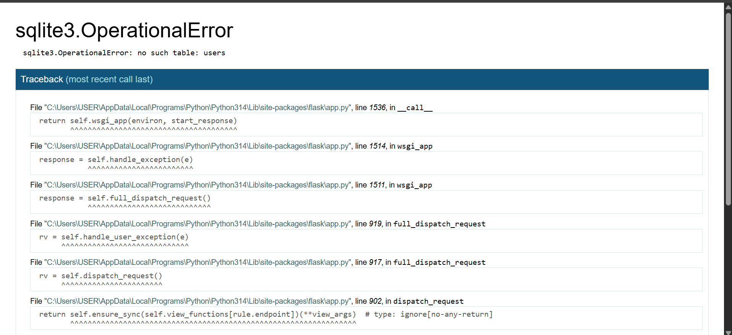
6.0 DEPLOYMENT OF STATIC APPLICATION SECURITY TESTING (SAST) TOOL
I successfully installed the Python static analysis tool ‘Bandit’ via the pip package manager to perform an automated source code security audit. Bandit is specifically designed to parse Python source code, build an Abstract Syntax Tree (AST), and run target plugins against it to identify common security flaws, misconfigurations, and known risky coding patterns prior to deployment.
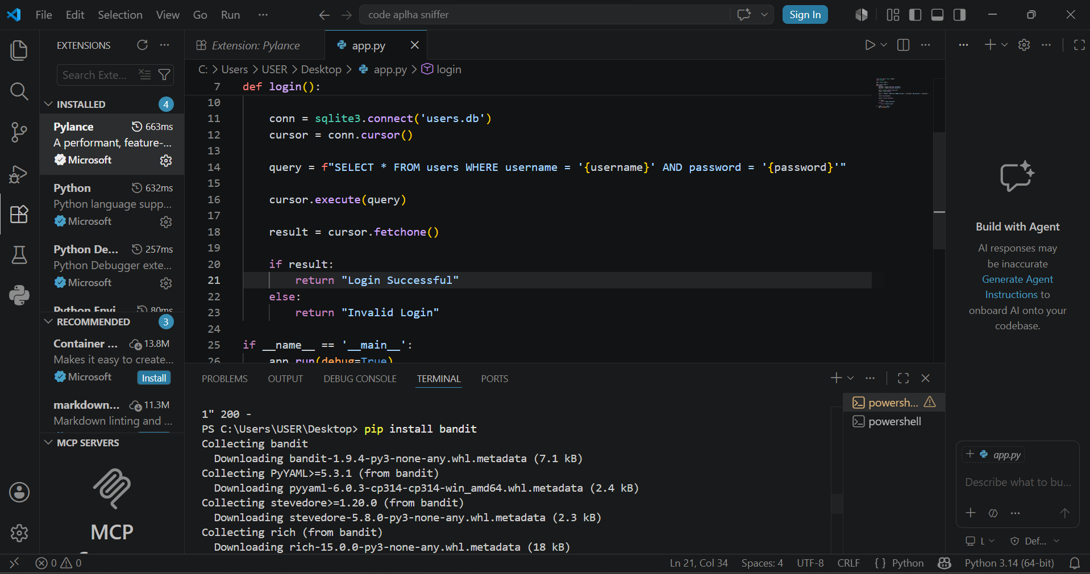
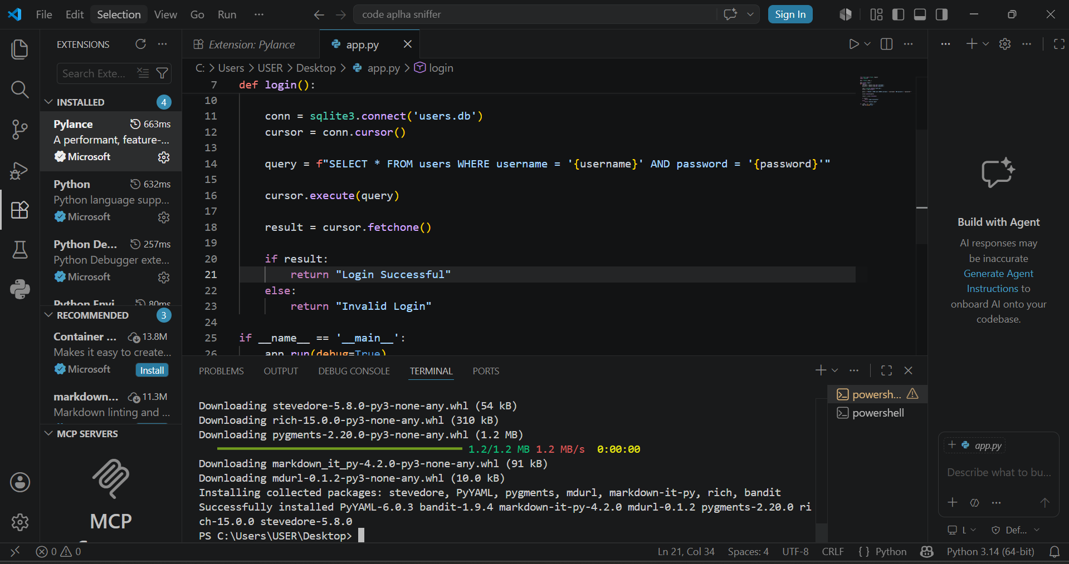

6.1 AUTOMATED SAST VULNERABILITY ANALYSIS – SQL INJECTION
The static analysis engine flagged a Medium-severity security flaw code-named B608 (hardcoded_sql_expressions) inside the login route logic at line 14. The application structures its backend database search by concatenating raw, untrusted user inputs directly into an SQL command string via Python f-strings. This implementation bypasses standard data sanitization gates, leaving the application heavily exposed to SQL Injection (CWE-89) parameters where malicious actors could manipulate raw query structures to bypass authorization logic entirely.
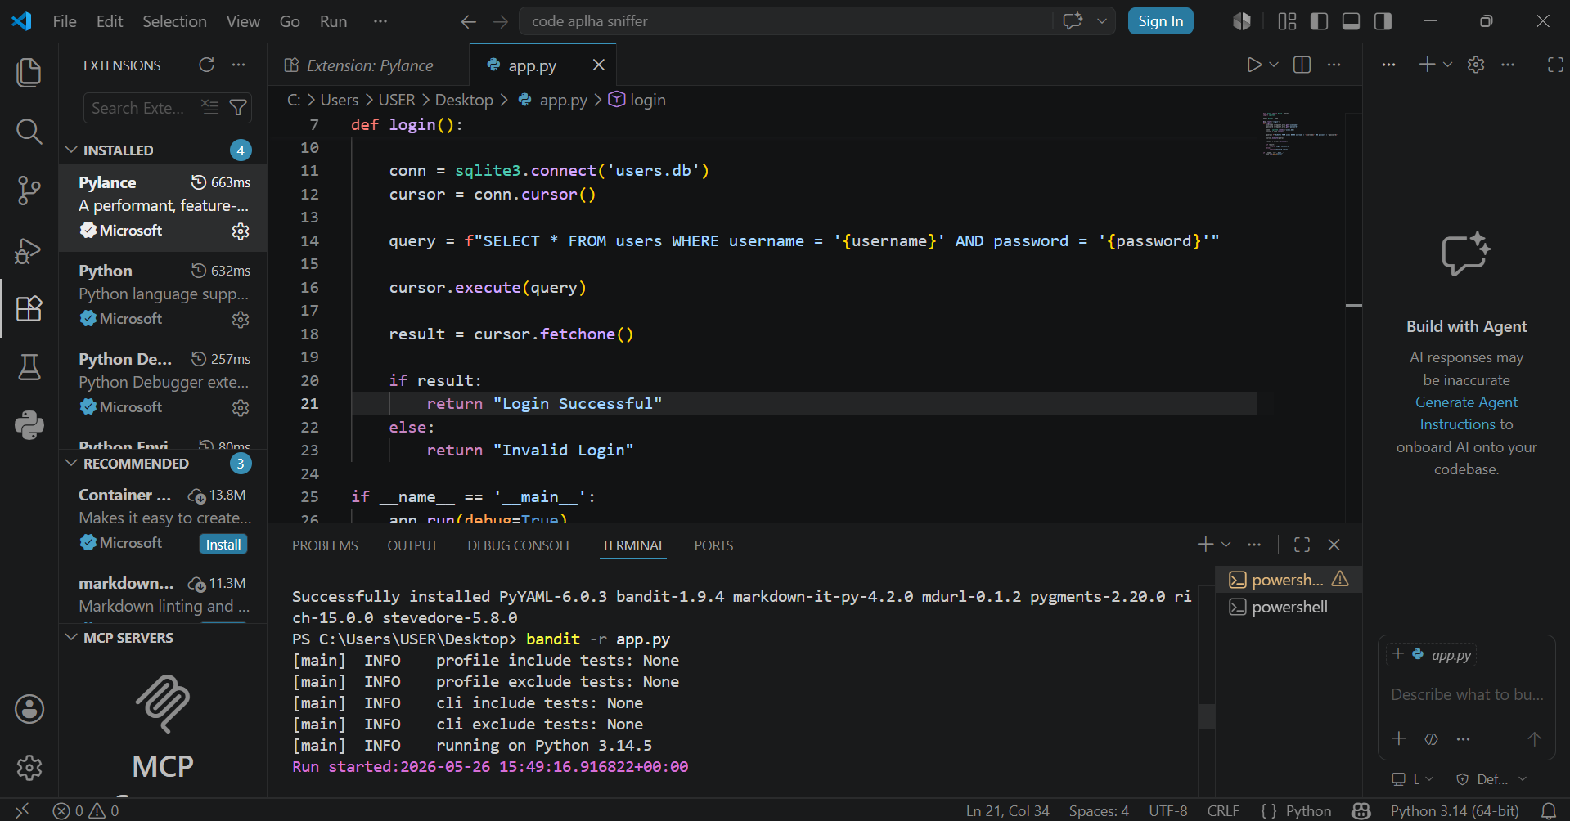
6.2 AUTOMATED SAST VULNERABILITY ANALYSIS – CONFIGURATION FLAW
Bandit flagged a High-severity infrastructure flaw code-named B201 (flask_debug_true) on execution line 26. Deploying a web application framework with the parameter debug=True initiates an active development context within production. This setting prints highly verbose interactive traceback maps directly onto browser environments during runtime errors. This configuration flaw (CWE-94) facilitates detailed server reconnaissance, leaks sensitive paths, and allows remote clients to execute arbitrary system expressions.
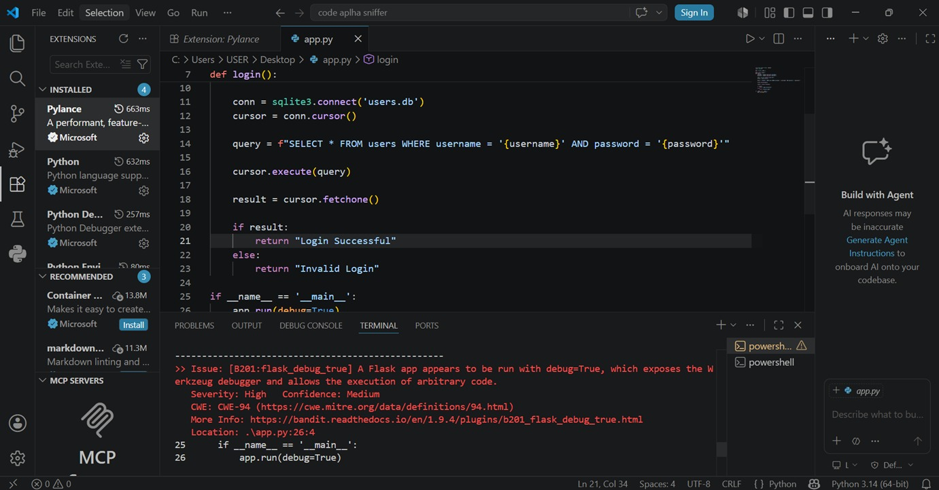
6.3 STATIC CODE AUDIT METRIC AGGREGATION
The concluding section of the automated audit aggregates total quantitative data discovered across the codebase matrix. Testing verified a total surface area of 18 functional python instructions. The diagnostic scanner cataloged exactly two distinct weaknesses: one Medium-severity risk and one High-severity configuration vulnerability. These actionable security intelligence metrics define the exact baseline for the remediation phase of this secure lifecycle project.
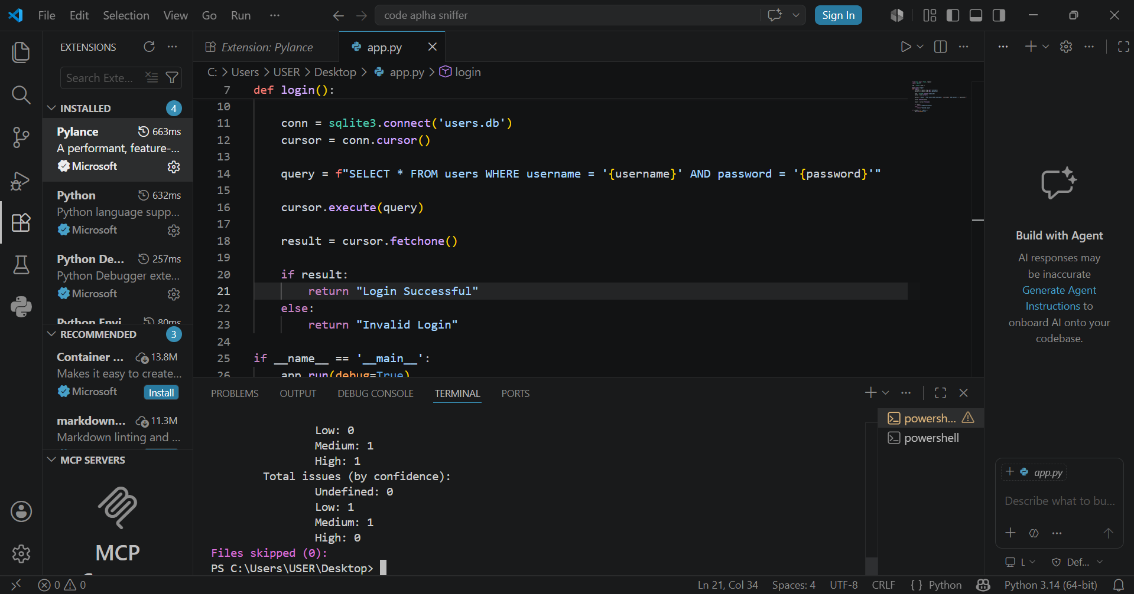

7.0 IMPLEMENTATION OF SOURCE CODE PATCHES
To formally eliminate the identified architectural risks, the application source code was comprehensively refactored using industry-standard secure coding principles. The original implementation, which evaluated user variables dynamically through string concatenation, was replaced with database parameterization using standard SQL placeholders (?). This approach cleanly decouples user input data from database command logic, neutralizing data-driven execution vectors. Furthermore, deployment configurations were hard-hardened by switching the execution block parameter to debug=False to close production-level information disclosure holes
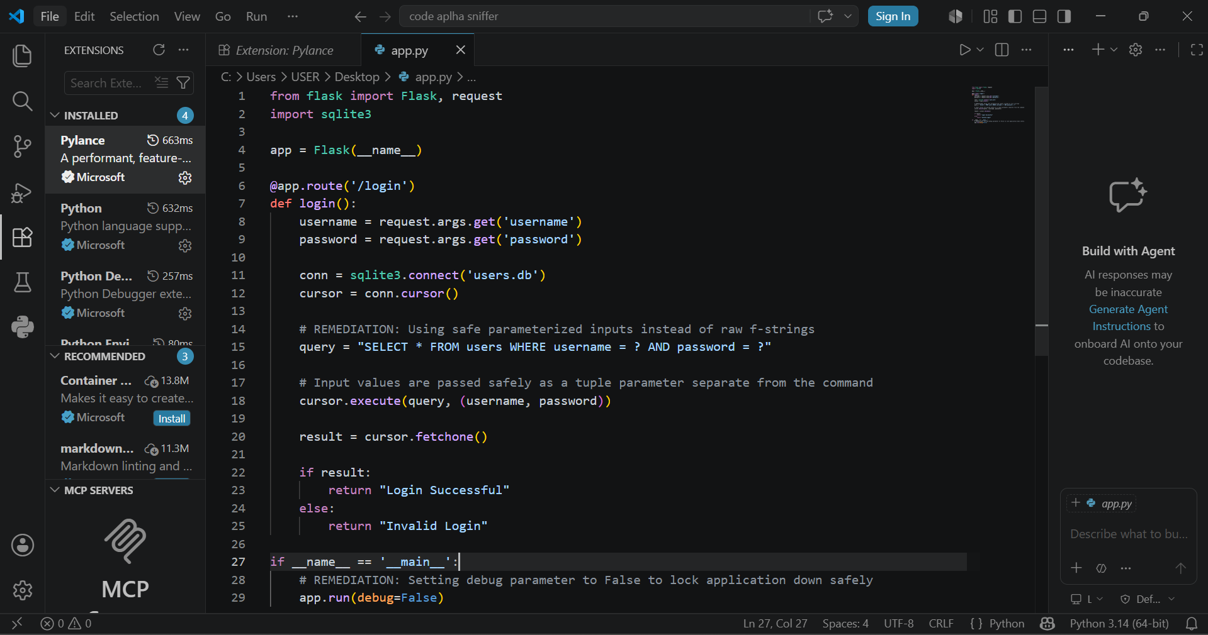
8.0 POST-REMEDIATION VERIFICATION SCAN
A secondary static application security testing (SAST) baseline was initiated following the source code refactoring phase to confirm patch efficacy. The diagnostic scanner successfully analyzed all 18 functional lines of python logic with zero ruleset exclusions. The post-remediation execution results returned zero total alerts across all evaluation layers, mathematically validating that the SQL Injection vector and the high-severity interactive debugger exposure were thoroughly eliminated from the architecture
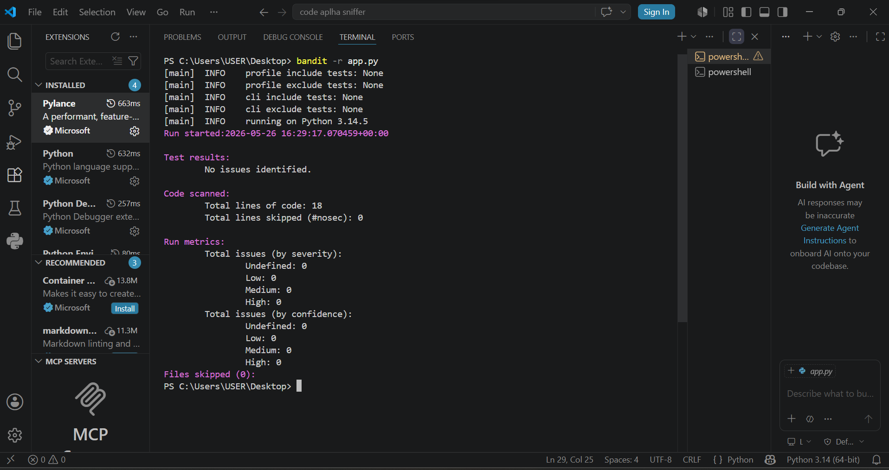

9.0 RECOMMENDATIONS AND BEST PRACTICES FOR CODING
1. DEFEND AGAINST INJECTION FLAWS (INPUT HANDLING)
Injection vulnerabilities occur whenever untrusted user data is combined with system commands or query strings without proper separation.
USE PARAMETERIZED QUERIES / PREPARED STATEMENTS: This is the absolute gold standard for preventing SQL Injection (SQLi). Parameterization separates executable code from the user data. Placeholders ensure the database treats input strictly as a literal value, never as command logic.

ENFORCE STRICT INPUT VALIDATION: Validate all input at the server level using an "allowlist" approach (defining what characters are explicitly allowed, rather than trying to block bad characters). Ensure values match expected data types, lengths, and regex formats before passing them deeper into the app.
Context-Aware Output Encoding: If user data is displayed back to the user on a web interface, encode characters (like converting < to &lt;) to prevent Cross-Site Scripting (XSS) vulnerabilities.

2. IMPLEMENT SECURE CONFIGURATION MANAGEMENT
Software frameworks often ship with default settings optimized for speed and easy debugging during development, but these defaults must be hardened for production deployment.

DISABLE DEBUGGING MODES GLOBALLY: Flags like debug=True in web frameworks must be strictly set to False in testing and live environments. This prevents verbose framework error screens from leaking directory maps, variables, and runtime stacks to unauthorized clients.

GRACEFUL, GENERIC ERROR HANDLING: Implement global exception blocks to catch internal application or database crashes cleanly. Return a user-friendly generic error message (e.g., "An unexpected system anomaly occurred. Please contact an administrator.") while recording the precise technical error details securely into private internal server logs.

RESTRICT SERVICE PRIVILEGES (PRINCIPLE OF LEAST PRIVILEGE): Ensure that the database user account or service worker running the application only possesses the exact permissions necessary to function. For example, a web login endpoint script should never run using a database root or admin account; it should be restricted to a read/write user with no drop or schema modification privileges.

3. ESTABLISH CONTINUOUS AUTOMATED SECURITY TESTING
Manual peer reviews are invaluable for business logic verification, but scaling security across a growing codebase requires automated guardrails.

INTEGRATE SAST INTO BUILD PIPELINES: Embed Static Application Security Testing (SAST) utilities (such as Bandit for Python, SonarQube, or Semgrep) directly into continuous integration/continuous deployment (CI/CD) workflows. This automatically flags risky methodologies, hardcoded configurations, or insecure library paths before pull requests can be merged.

SOFTWARE COMPOSITION ANALYSIS (SCA): Modern code relies heavily on open-source dependencies. Use automated dependency scanners to parse framework libraries against known vulnerability databases (like CVE catalogs) to catch obsolete, unpatched packages before production exposure.

